Press Release
Ciara O’Hara
Place

Riverside Café Gallery, Farnham Maltings
28 May – 01 July 2016

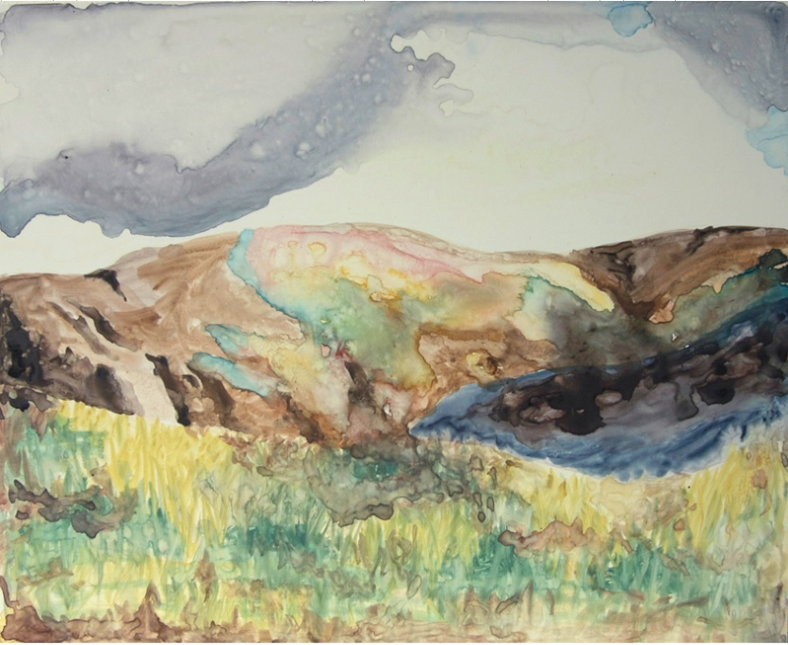
This work explores landscape and travel, an interest which was prompted by Irish artist Ciara O’Hara’s recent move to England. The works in this exhibition are based on photographs taken during her travels to Iceland, Scotland, England and Ireland. They convey the fleeting relationship which exists when we, as outsiders, pass through a new landscape.
These landscapes are unique and serve as an identity of a place. Ciara’s work captures this identity, while acknowledging that we all perceive these scenes through the lens of our own personal experiences. The viewer can place their own associations and narratives on a landscape, be it a memory, a story heard in childhood or the people with whom the experience of this scenery is shared.

All works are for sale, please enquire at Box Office.

Ciara O'Hara is an Irish visual artist based in south of England. She graduated in 2006 with a BA (hons) in Fine Art Printmaking and Art History from National College of Art and Design, Dublin; she also has a MA in Cultural Policy and Arts Management from University College Dublin. This is her first solo exhibition in England. Her most recent solo exhibition was held at Custom House Studios & Gallery in Westport, Co. Mayo, Ireland in September 2015. Ciara has previously exhibited in galleries throughout Ireland, Iceland and England. She has taken part in three artist residencies in Iceland in 2009 and 2012. Her work is part of the Office of Public Works, University College Dublin, Town of Skagastrond and several private collections.
www.ciaraohara.com

